

Instead of fetching bunch of dependencies: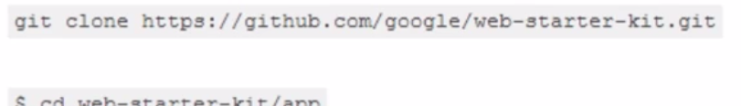

We can do easily as: 



* Get project up and running..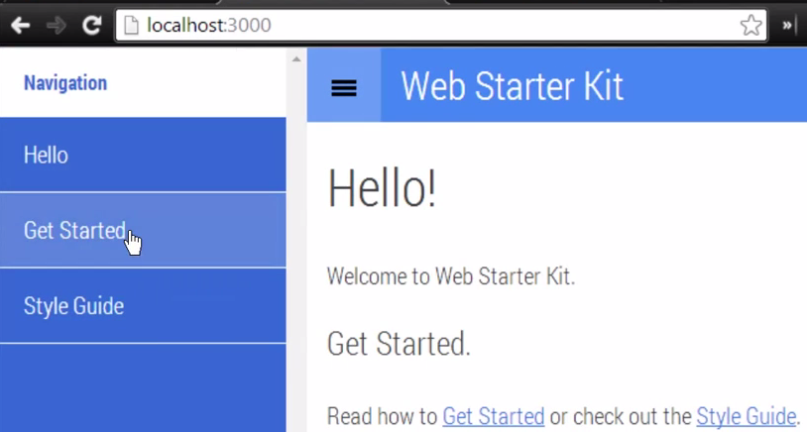 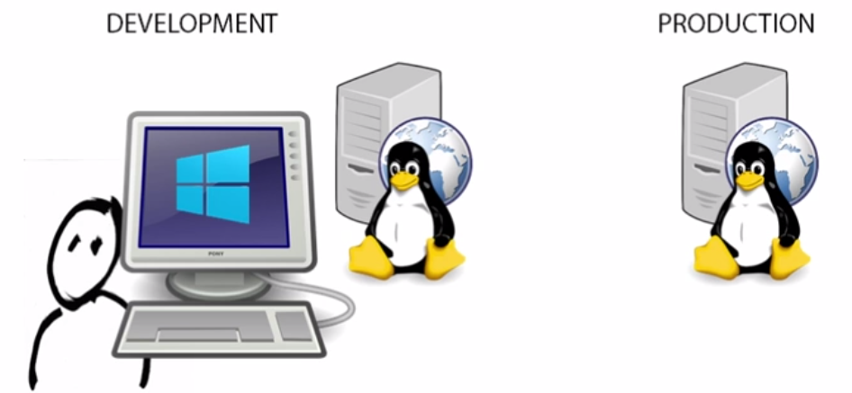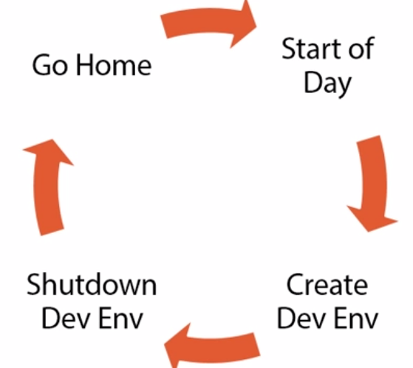 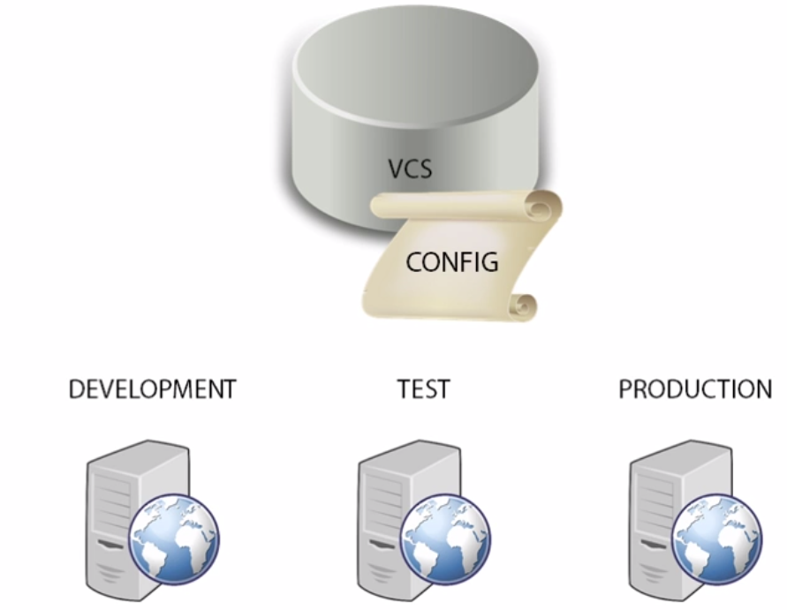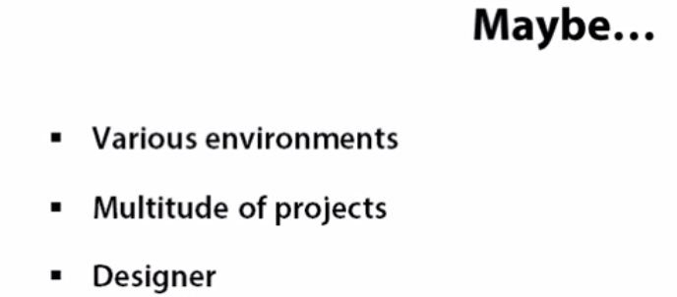

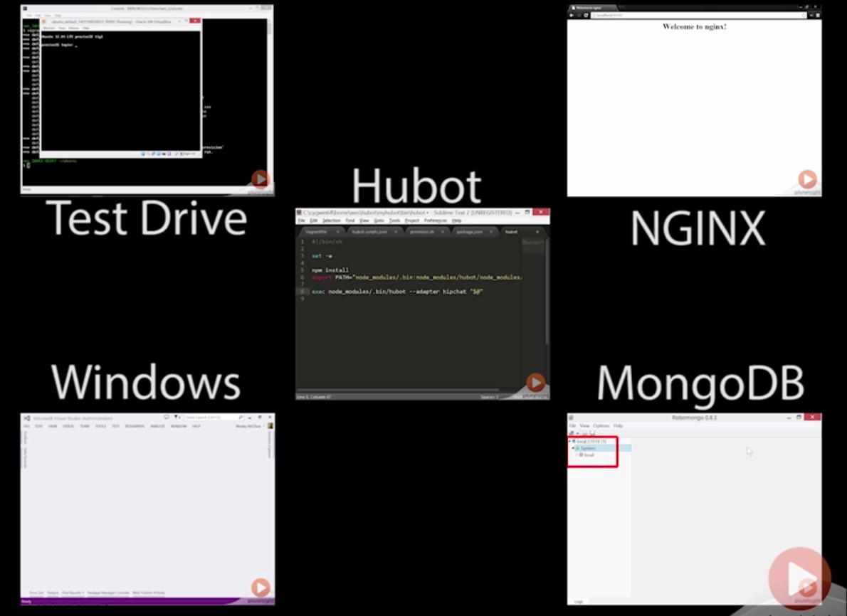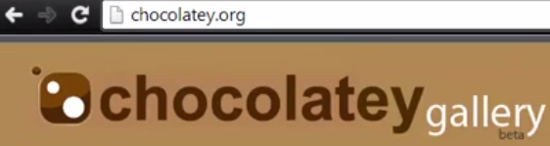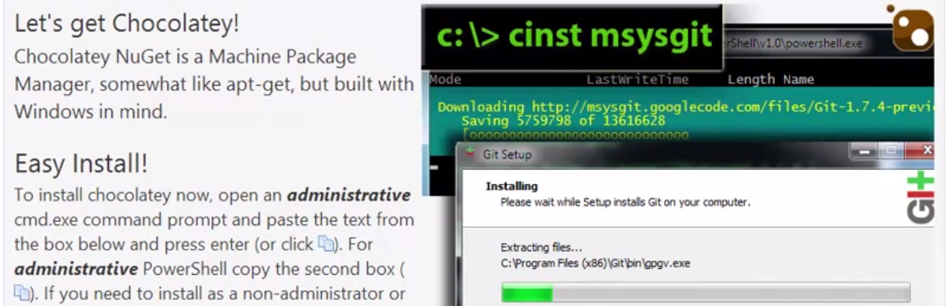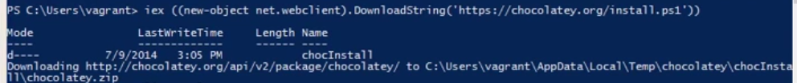

We also need ssh and rync also …For this use cygwin..Msysgit doent have rsync(minial cygwin installation)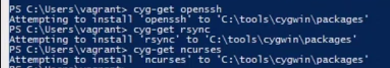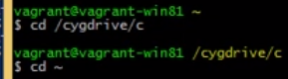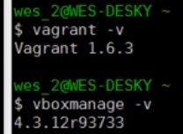Vagrant 1.6 or newer… VBox 4.3.12 or newer..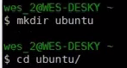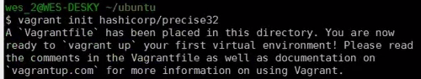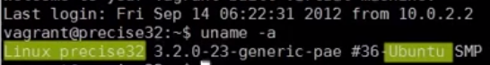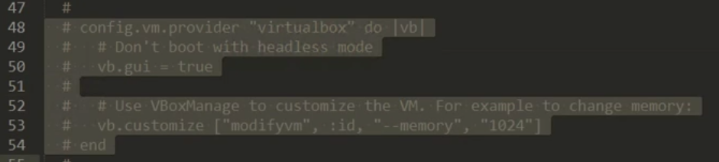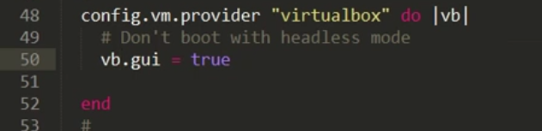

Uncomment and leave vb.gui=true-🡪 It don’t boot in headless mode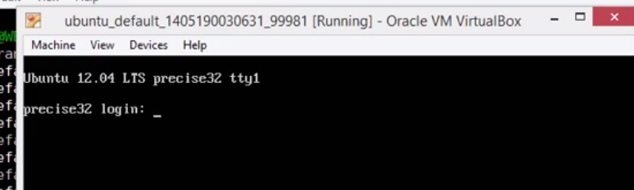

**Sharing files:**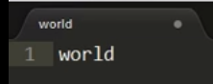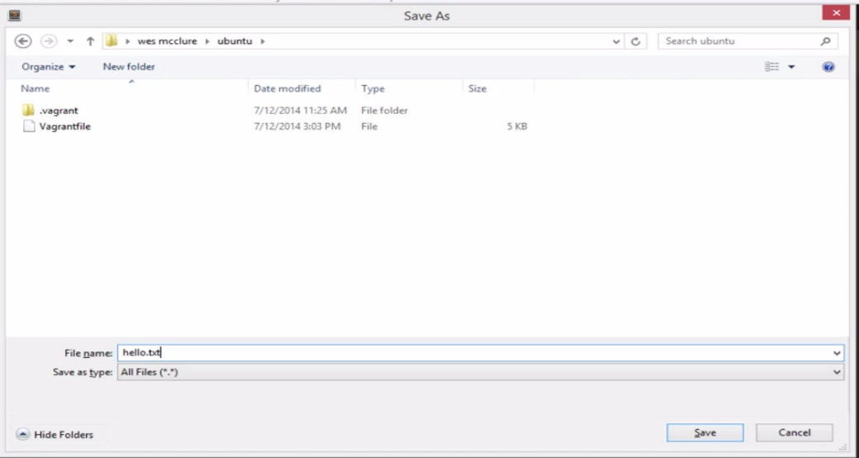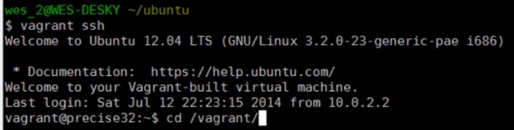

**Environment specific to each project:**

**When we want to switch project or when we are done for the day with day: we want to free up resources for other purposes..**

**1.)Poweroff**

**2.) suspend VM—like Hibernate The current running state will be preserved including contents of VM and entire FS of VM. All this will be stored on disk.VM will be no longer running.**

**This will free up memory resources and CPU on machine**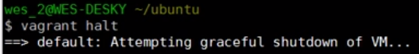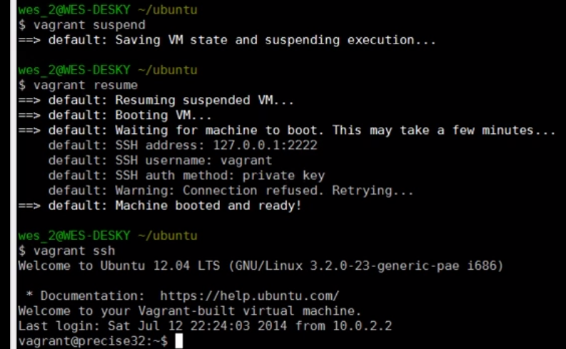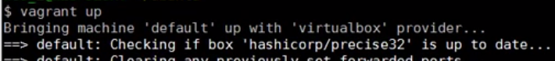

**Note: make sure you are on command prompt…Now in ssh with guest**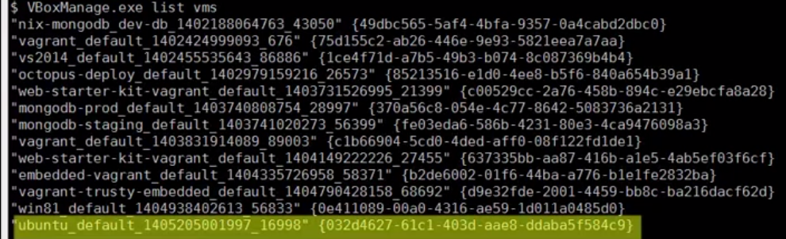

**New VM is created** 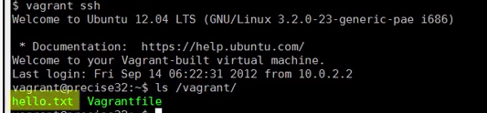

**Make sure you checkedout files from repo with linefeed only. This will help to revert back.**

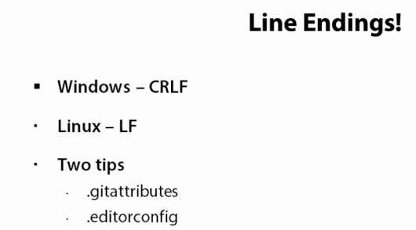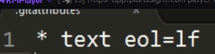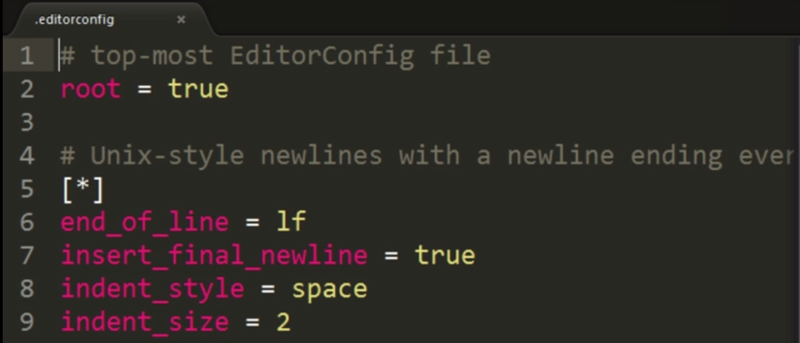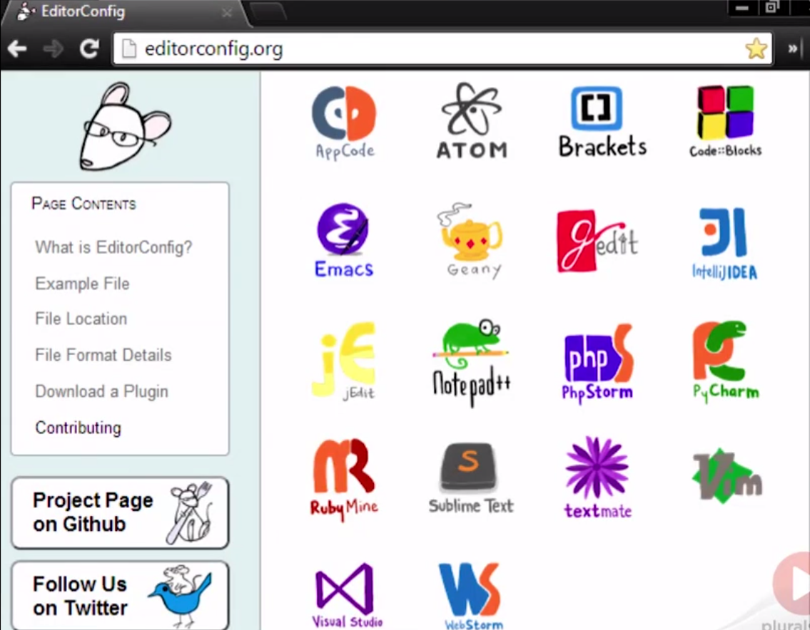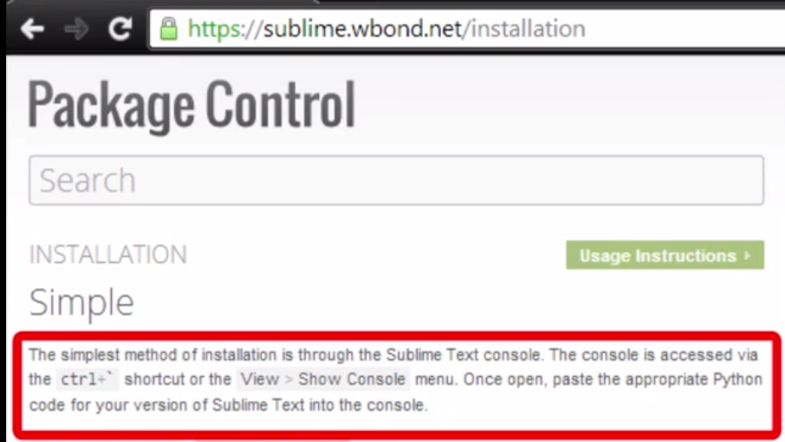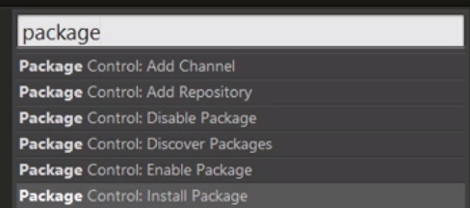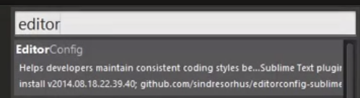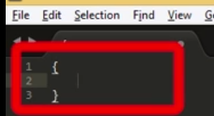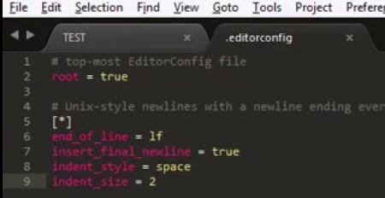

**Place .editorconfig on same directory as TEST { } file**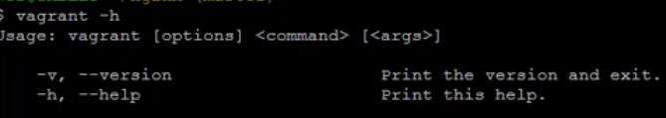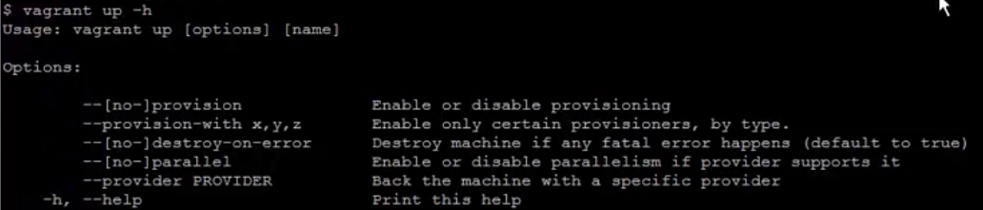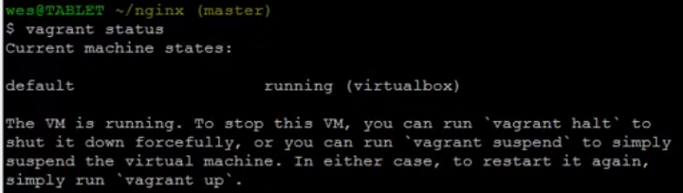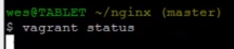

**We will get a lot of info. now**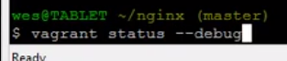

**We can also pass debug as below:**